Ideation Phase
Empathize & Discover

Date | 20 October 2026
Team ID | [Enter Team ID]
Project Name | Electric Vehicle Market Performance & Insights
Maximum Marks | 4 Marks

Empathy Map Canvas:
An empathy map is a simple, easy-to-digest visual that captures knowledge about a user’s behaviours and attitudes.

It is a useful tool to helps teams better understand their users.
Creating an effective solution requires understanding the true problem and the person who is experiencing it. The exercise of creating the map helps participants consider things from the user’s perspective along with his or her goals and challenges.
Example:
Reference: https://www.mural.co/templates/empathy-map-canvas

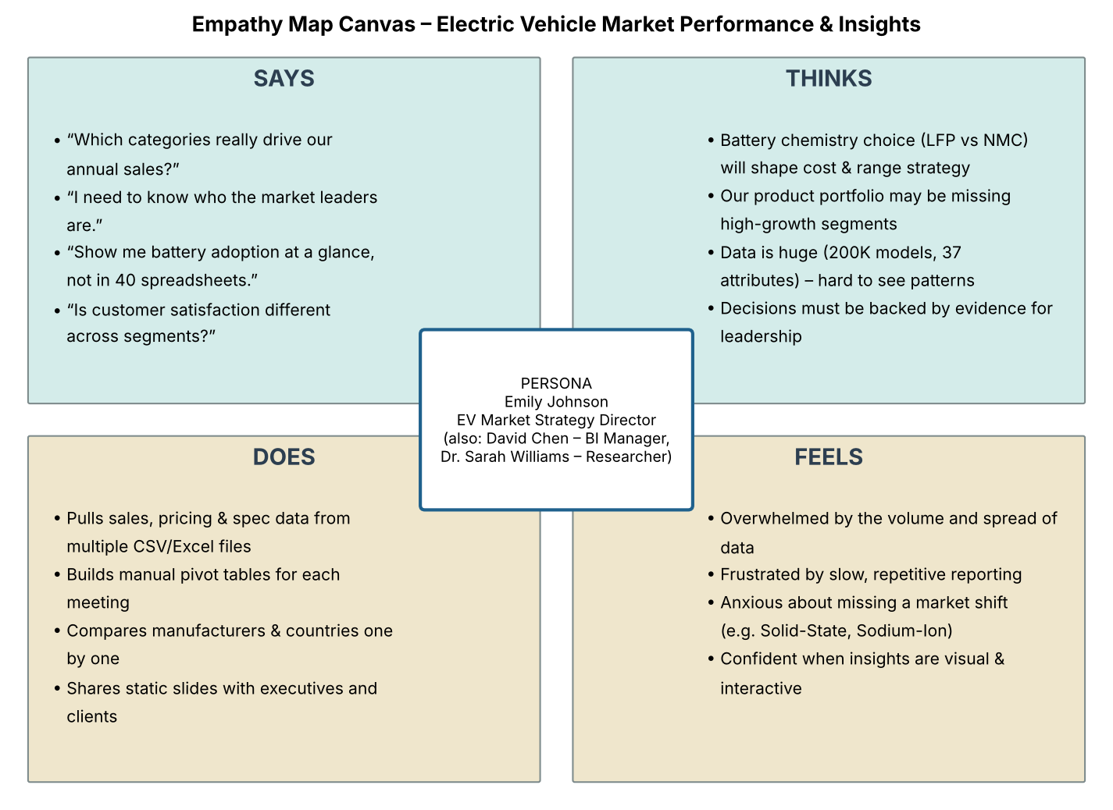

Persona summary: Emily Johnson (EV Market Strategy Director) is the primary persona. She is supported by David Chen (Automotive BI Manager), who tracks manufacturer market share and production geography, and Dr. Sarah Williams (Sustainable Mobility Research Analyst), who compares battery technologies, driving range and customer satisfaction. All three need one interactive, visual view of a 200,000-model EV dataset instead of manual spreadsheets.

